

SCHOOL OF COMPUTING

Department of Computer Science and Engineering

DATA ANALYSIS ESSENTIALS

CERTIFICATE

This is to certify that the Cornerstone project work entitled “WEATHER DATA ANALYSIS” is submitted by
P.Raghu Ram | (25B11CS746)
p.Abhi Varun Reddy | (25B11CS692)
M.sSiva Murali Krishna | (25B11CS631)
P.S.S Rohith Kumar | (25B11CS752)

in partial fulfillment of the requirements for the award of the B.Tech. degree in Computer Science and Engineering for the academic year 2026-2027.

Project Guide Head of the Department
Dr. Phani Sridhar Addepalli, Ph.D, Dr. Phani Sridhar Addepalli, Ph.D,
Assistant Professor, Assistant Professor,
Department of CSE Department of CSE

DECLARATION

We hereby declare that the Cornerstone project entitled “WEATHER DATA ANALYSIS” is original and is submitted to ADITYA UNIVERSITY, Surampalem, in partial fulfillment of the requirements for the award of the B.Tech. Degree in Computer Science and Engineering. We further declare that this project work has not been submitted, either in full or in part, for the award of any degree in this or any other institution. We also confirm that this work complies with the Institutional Academic Integrity and AI Usage Policy

Place: Surampalem
Date:
By
P.Raghu Ram | (25B11CS746)
p.Abhi Varun Reddy | (25B11CS692)
M.sSiva Murali Krishna | (25B11CS631)
P.S.S Rohith Kumar | (25B11CS752)

ACKNOWLEDGEMENT
It is with immense pleasure that we express our sincere gratitude to our Cornerstone Project Guide, Dr. Phani Sridhar Addepalli, Ph.D, Assistant Professor, who has guided us throughout the project. Her valuable support, encouragement, and guidance have greatly contributed to the successful completion of this work.
We would like to thank our Deputy Heads of the Department, Dr. Chandra Sekhar Kolli, Associate Professor, Dr Hari Jyothula, Associate Professor and Dr Pennada Siva Satya Prasad, Assistant Profeesor, Department of Computer Science and Engineering, for their support and valuable suggestions.
Our deepest thanks to our Head of the Department Dr. Phani Sridhar Addepalli, Assistant Professor, for his inspiration and for providing all the necessary facilities and resources required for this project.
We also extend our sincere thanks to Dr. M.V. Rajesh, Associate Dean, School of Computing for their encouragement and support during the course of our project.
We would like to express our sincere gratitude to Dr. G. Suresh, Registrar, Dr. A Ramesh, Pro Vice-Chancellor (Engineering & Sciences), Dr. S. Rama Sree, Pro Vice-Chancellor (Academics), Dr. M.B. Srinivas, Vice-Chancellor, Dr. M. Sreenivasa Reddy, Deputy Pro Chancellor and Management, Aditya University for providing excellent infrastructure and state-of-the-art laboratories.
Finally, we would like to thank the faculty members, lab technicians, non-teaching staff, and our friends who have directly or indirectly supported us in completing this Cornerstone project successfully.

ABSTRACT
This Cornerstone project, entitled "WEATHER DATA ANALYSIS", conducts an exhaustive exploratory data analysis (EDA) and analytical investigation of multi-decadal meteorological patterns across ten major Indian metropolitan centers over a twenty-five-year period (2000–2024). Utilizing a comprehensive meteorological repository of over 91,000 daily observations encompassing maximum, minimum, and apparent temperatures, precipitation levels, weather condition codes, and wind dynamics, the project systematically carries out rigorous data preprocessing, audit of missing values, and elimination of multicollinear parameters.
Advanced descriptive statistics and publication-quality visual graphics are synthesized to examine empirical distributions, seasonal shifts across the four distinct Indian meteorological regimes (Winter, Summer, Monsoon, and Post-Monsoon), and localized micro-climatic divergences between inland continental cities and maritime coastal zones. The empirical findings reveal heavy zero-inflation in daily precipitation requiring logarithmic transformations, distinct diurnal temperature compression during cloud-dense monsoon regimes, and a statistically observable decadal warming trend (+0.51°C) in average maximum temperatures across urban India over the quarter-century observation baseline. The developed analytical pipeline establishes a dependable benchmark for meteorological evaluation, climate risk awareness, and urban environmental planning.

TABLE OF CONTENTS
Certificate i
Declaration ii
Acknowledgement iii
Abstract iv
Table of Contents v
List of Figures vi
List of Tables vii
CHAPTER 1 - INTRODUCTION 1
1.1 Introduction to the Project 1
1.2 Problem Statement 1
1.3 Objectives of the Project 2
1.4 Scope of the Project 2
CHAPTER 2 - DATASET DESCRIPTION AND UNDERSTANDING 3
2.1 Dataset Source 3
2.2 Dataset Description 3
2.3 Features / Attributes 3
2.4 Key Target / Analyzed Variables 3
2.5 Dataset Statistics / Initial Exploration 3
CHAPTER 3 - DATA PREPROCESSING 4
3.1 Data Collection / Loading 4
3.2 Handling Missing Values 4
3.3 Handling Duplicate / Inconsistent Data 4
3.4 Feature Scaling 4
3.5 Standardization 4
3.6 Label Encoding 4
3.7 One-Hot Encoding 5
3.8 Other Project-Specific Preprocessing 5
CHAPTER 4 - SYSTEM DESIGN AND METHODOLOGY 6
4.1 Proposed Methodology 6
4.2 System Workflow / Architecture 6
4.3 Flowchart 7
4.4 Tools and Technologies Used 7
CHAPTER 5 - IMPLEMENTATION 9
5.1 Development Environment 9
5.2 Dataset Loading and Exploration 9
5.3 Preprocessing Implementation 9
5.4 Exploratory Data Analysis (EDA) Implementation 10
CHAPTER 6 - DATA VISUALIZATION AND RESULTS 13
6.1 Bar Graphs 13
6.2 Histograms 14
6.3 Box Plots 16
6.4 Line Charts 17
6.5 Scatter Plots 19
CHAPTER 7 - OUTPUT SCREENSHOTS 21
7.1 Input / Dataset Screenshots 21
7.2 Preprocessing Outputs 22
CHAPTER 8 - CONCLUSION AND FUTURE ENHANCEMENTS 25
8.1 Conclusion 25
8.2 Limitations 25
8.3 Future Enhancements 25

LIST OF FIGURES
Figure 4.1: Workflow Flowchart of the Weather Data Analytics System 7
Figure 6.1: Average Maximum Temperature by City (2000–2024) 13
Figure 6.2: Average Daily Precipitation by City (2000–2024) 13
Figure 6.3: Weather Condition Frequency across India (2000–2024) 14
Figure 6.4: Distribution of Daily Maximum Temperature Across All Cities 14
Figure 6.5: Distribution of Precipitation: Raw vs Log-Transformed 15
Figure 6.6: Max vs Min Temperature Distribution 15
Figure 6.7: Maximum Temperature vs Seasons Box Plot 16
Figure 6.8: Precipitation vs Seasons Box Plot 16
Figure 6.9: Max Temperature Distribution by City Box Plot 17
Figure 6.10: Yearly Average Max Temperature Trend (2000–2024) 17
Figure 6.11: Yearly Average Precipitation Trend (2000–2024) 18
Figure 6.12: Average Monthly Maximum Temperature Seasonality 18
Figure 6.13: Average Monthly Precipitation Seasonality 19
Figure 6.14: Maximum Temperature vs Precipitation Scatter Plot 19
Figure 6.15: Wind Speed vs Wind Gusts Scatter Plot 20
Figure 6.16: Temperature vs Apparent Temperature Scatter Plot 20
Figure 7.1: Screenshot of input data 21
Figure 7.2: Output of .head() method 22
Figure 7.3: Output of the .info() method in pandas 23
Figure 7.4: Output of df.is_null().sum() method 23
Figure 7.5: Output of .describe method 24

LIST OF TABLES
Table 2.1: Raw Dataset Attributes and Descriptions 3
Table 2.2: Statistical Summary of the Raw Numerical Features 3
Table 3.1: Indian Meteorological Season Categorization 5
Table 4.1: Tools and Technologies Used in the Project 8

CHAPTER 1-INTRODUCTION

1.1 Introduction to the Project
Meteorology and atmospheric analytics form the cornerstone of environmental sciences, agricultural planning, public health governance, water management, and urban disaster preparedness. In a diverse subcontinent like India, which encompasses Himalayan topography, fertile river basins, arid deserts, Deccan plateaus, and extensive tropical coastlines, daily meteorological conditions exhibit substantial spatiotemporal variability. Analyzing historical atmospheric records offers indispensable insights into climate shifts, seasonal onset patterns, monsoon intensity, and micro-climatic divergences across metropolitan centers.
Modern Data Analytics and Exploratory Data Analysis (EDA) provide powerful quantitative techniques to extract hidden patterns, identify distributional properties, detect anomalous climate extremes, and uncover multivariate correlations from complex high-dimensional datasets. Rather than viewing weather data merely as raw numbers, data analytics empowers data scientists and domain experts to visualize temperature trajectories, quantify precipitation skewness, and assess the empirical reality of climate warming over quarter-century observation windows.
This Cornerstone project, entitled "WEATHER DATA ANALYTICS SYSTEM", conducts an extensive data-driven exploration of twenty-five years (2000–2024) of daily weather records across ten major Indian metropolises. Utilizing modern Python data engineering, descriptive statistics, and publication-quality visual graphics, this project provides a definitive analytical baseline documenting the thermal, hydrologic, and wind dynamics of urban India.

1.2 Problem Statement
Analyzing historical weather data across India involves significant analytical and statistical hurdles stemming from the complex physics of tropical atmospheres and regional geographical heterogeneity. Specifically, this study addresses the following key challenges:
- 1. Extreme Non-Gaussian Skewness and Zero-Inflation: Daily precipitation records across Indian cities are heavily zero-inflated (over 70% of days experience zero rainfall), rendering standard Gaussian assumptions invalid and requiring specialized logarithmic transformations.
- 2. Regional Micro-Climatic Divergence: Continental northern inland cities (such as Delhi and Jaipur) experience dramatic annual temperature ranges (10°C to 48°C), whereas maritime coastal cities (such as Mumbai and Chennai) exhibit oceanic moderation, requiring localized comparative exploration.
- 3. Collinearity and Data Redundancy: Meteorological observation archives frequently contain duplicate or perfectly collinear attributes (such as rain_sum and precipitation_sum), requiring systematic audit and sanitization.
- 4. Decadal Climate Warming Detection: Disentangling subtle long-term climate warming trends from severe intra-annual seasonal swings requires multi-decade aggregations and continuous time-series visualization.

1.3 Objectives of the Project
The foundational objectives of this Data Analysis Cornerstone project are:
- Objective 1: To ingest, sanitize, and preprocess a comprehensive 25-year daily weather dataset (91,320 records) spanning ten major Indian cities from 2000 to 2024.
- Objective 2: To identify, audit, and remove redundant duplicate features (such as collinear rainfall measures) and structure chronological time-series indexes.
- Objective 3: To engineer domain-specific meteorological features, including Indian seasonal classification, diurnal temperature range, apparent feels-like thermal spread, wind gust ratios, and logarithmic rainfall transformations.
- Objective 4: To conduct an extensive Exploratory Data Analysis (EDA) across nineteen statistical figures, covering univariate distributions, seasonal box plots, annual warming trends, and multivariate scatter relationships.
- Objective 5: To compute and interpret Pearson correlation matrices across all continuous meteorological features to establish the thermodynamic principles linking cloud cover, diurnal temperature depression, and moisture.
- Objective 6: To synthesize descriptive statistical findings into actionable agro-meteorological and urban environmental insights.

1.4 Scope of the Project
The scope of this project encompasses 91,320 daily meteorological observations recorded over 9,132 consecutive days between January 1, 2000 and December 31, 2024. The geographical scope spans ten major Indian administrative, commercial, and geographic centers representing India's primary agro-climatic zones: Delhi, Mumbai, Kolkata, Chennai, Bangalore, Hyderabad, Pune, Ahmedabad, Jaipur, and Lucknow.
The deliverables include a preprocessed dataset (`preprocessed.csv`), nineteen high-resolution statistical visualization charts (`charts/`), reusable Python notebooks (`preprocessing.ipynb` and `eda.ipynb`), and complete university-standard academic documentation.

CHAPTER 2
DATASET DESCRIPTION AND UNDERSTANDING

2.1 Dataset Source
The dataset utilized in this project, titled `india_2000_2024_daily_weather.csv`, was curated from historical meteorological archives and the Open-Meteo Historical Weather API, harmonized with observation benchmarks established by the India Meteorological Department (IMD). The dataset captures surface temperature, apparent 'feels-like' temperature, precipitation accumulation, atmospheric weather codes, and surface wind vector dynamics.

2.2 Dataset Description
The raw dataset consists of exactly 91,320 rows and 12 columns. Each row corresponds to a single calendar day of weather observations for a specific city. The temporal span covers twenty-five full calendar years (2000 to 2024), providing 9,132 daily records per city without temporal gaps.

2.3 Features / Attributes
The raw dataset attributes, physical units, data types, and physical descriptions are detailed in Table 2.1.
Table 2.1: Raw Dataset Attributes and Descriptions
Feature Name | Data Type | Unit | Physical Description
city | Categorical / String | N/A | Name of the Indian metropolitan city (10 unique cities).
date | Temporal / String | YYYY-MM-DD | Observation date ranging from 2000-01-01 to 2024-12-31.
temperature_2m_max | Continuous / Float | °C | Maximum air temperature measured at 2 meters above ground level.
temperature_2m_min | Continuous / Float | °C | Minimum air temperature measured at 2 meters above ground level.
apparent_temperature_max | Continuous / Float | °C | Maximum perceived 'feels-like' temperature incorporating humidity & wind.
apparent_temperature_min | Continuous / Float | °C | Minimum perceived 'feels-like' temperature incorporating humidity & wind.
precipitation_sum | Continuous / Float | mm | Total cumulative liquid water precipitation recorded over 24 hours.
rain_sum | Continuous / Float | mm | Total daily rainfall sum (redundant duplicate of precipitation_sum).
weather_code | Discrete / Integer | WMO Code | World Meteorological Organization numeric code denoting weather condition.
wind_speed_10m_max | Continuous / Float | km/h | Maximum sustained horizontal wind speed measured at 10m height.
wind_gusts_10m_max | Continuous / Float | km/h | Maximum instantaneous wind gust speed measured at 10m height.
wind_direction_10m_dominant | Continuous / Float | Degrees (°) | Dominant azimuth wind direction (0° to 360°, where 0°=North).

2.4 Key Target / Analyzed Variables
This is a data analytics project; no target variable is predicted. The analysis instead focuses on the principal analyzed variables: maximum and minimum temperature, apparent temperature, precipitation, wind speed and gusts, together with the derived season and city groupings used for comparison.

2.5 Dataset Statistics / Initial Exploration
Table 2.2 provides a comprehensive statistical summary of the raw numerical meteorological features computed across all 91,320 observations in the dataset.
Table 2.2: Statistical Summary of the Raw Numerical Features
Metric | Count | Mean | Std | Min | 25% | 50% | 75% | Max
temperature_2m_max | 91,320 | 32.18 | 5.21 | 8.90 | 28.90 | 32.40 | 35.60 | 49.20
temperature_2m_min | 91,320 | 20.65 | 5.83 | 0.60 | 16.40 | 22.10 | 25.30 | 35.10
apparent_temperature_max | 91,320 | 35.29 | 7.19 | 7.60 | 30.40 | 35.30 | 40.30 | 56.40
apparent_temperature_min | 91,320 | 22.58 | 7.84 | -0.80 | 16.80 | 24.60 | 28.90 | 41.60
precipitation_sum | 91,320 | 2.89 | 10.42 | 0.00 | 0.00 | 0.00 | 0.60 | 420.50
wind_speed_10m_max | 91,320 | 13.68 | 5.45 | 1.80 | 9.70 | 12.70 | 16.70 | 78.50
wind_gusts_10m_max | 91,320 | 30.45 | 11.12 | 5.40 | 22.30 | 28.80 | 36.70 | 138.60
wind_direction_10m_dominant | 91,320 | 204.62 | 101.44 | 0.00 | 115.00 | 233.00 | 287.00 | 360.00
The descriptive statistics demonstrate significant physical variation: daily maximum temperatures reach as high as 49.20°C during summer heatwaves, while minimum temperatures drop to 0.60°C during northern winter cold snaps. Daily precipitation exhibits severe zero-inflation: the median (50th percentile) is 0.00 mm and the 75th percentile is only 0.60 mm, yet extreme tropical downpours record values up to 420.50 mm.

CHAPTER 3-DATA PREPROCESSING

3.1 Data Collection / Loading
Data loading is implemented using Python's `pandas` library. The raw CSV file is ingested into memory, verifying that all 91,320 rows and 12 columns are read properly without corrupted records. The total in-memory size of the raw dataset is 8.4 MB.

3.2 Handling Missing Values
A comprehensive missing value audit using `data.isnull().sum()` confirmed zero null values across all 12 raw attributes in the original dataset. In subsequent feature engineering steps where lag or rolling metrics are calculated, group-wise forward-fill followed by backward-fill (`df.groupby('city')[col].transform(lambda x: x.ffill().bfill())`) is applied within each city partition to preserve all 91,320 daily observations without dropping data.

3.3 Handling Duplicate / Inconsistent Data
An automated deduplication check (`data.drop_duplicates()`) confirmed that zero duplicate rows exist. Importantly, analytical auditing revealed that `rain_sum` is completely identical to `precipitation_sum` (`(data['precipitation_sum'] - data['rain_sum']).abs().max() == 0.0`). Retaining exact duplicate columns introduces severe multi-collinearity and memory redundancy; consequently, `rain_sum` was permanently dropped.

3.4 Feature Scaling
Continuous meteorological variables operate across disparate numerical scales: temperatures range from 0°C to 50°C, wind gusts range from 5 to 140 km/h, wind directions span 0° to 360°, and precipitation spans 0 to 420 mm. Feature scaling aligns these attributes into comparable numerical spaces for distance calculations and correlation analyses.

3.5 Standardization
Standardization (Z-score normalization) transforms continuous features to have zero mean (μ = 0) and unit variance (σ = 1):
Equation 3.1: z = (x - μ) / σ
This transformation stabilizes statistical variance, eliminates scale bias in multivariate distance metrics, and facilitates standardized regression comparisons.

3.6 Label Encoding
The discrete World Meteorological Organization numeric `weather_code` was mapped to qualitative semantic weather labels to enhance human interpretability. The mapping defines: Code 0: 'Clear sky'; Codes 1–3: 'Mainly clear / Partly cloudy / Overcast'; Codes 51–55: 'Drizzle'; Codes 61–65: 'Rain'; Codes 80–82: 'Rain showers'. For categorical grouping, `city` and `season` were encoded to unique numeric labels.

3.7 One-Hot Encoding
To avoid imposing an artificial numerical order onto nominal categories (such as implying that City 9 is 'greater than' City 1), one-hot dummy variables were created for `city` (10 binary indicator columns) and `season` (4 binary indicator columns), enabling unbiased categorical group comparisons.

3.8 Other Project-Specific Preprocessing
Domain-specific meteorological feature engineering was implemented to extract high-value physical signals. Table 3.1 displays the Indian meteorological season categorization mapping.
Table 3.1: Indian Meteorological Season Categorization
Season | Months Included | Meteorological Characteristics
Winter | December, January, February | Dry, cool continental air; low humidity, minimal precipitation across most of India.
Summer | March, April, May | Intense solar insolation, extreme daytime heating, high diurnal temperature spreads.
Monsoon | June, July, August, September | Southwest monsoon moisture surge, persistent cloud cover, heavy rainfall.
Post-Monsoon | October, November | Retreating monsoon, cyclonic depressions in the Bay of Bengal affecting coastal south India.

CHAPTER 4
SYSTEM DESIGN AND METHODOLOGY

4.1 Proposed Methodology
The proposed methodology follows a structured and reproducible data analytics lifecycle that converts the raw daily weather archive into validated statistical insight. Rather than building a predictive model, the methodology concentrates on understanding the data: auditing its quality, engineering meteorologically meaningful features, and exploring distributions, trends, and relationships through statistical summaries and visualizations. The methodology consists of six sequential stages.
Stage 1: Data Acquisition and Loading. The raw CSV file containing 91,320 rows and 12 columns is loaded into a pandas DataFrame and verified for structural integrity, data types, and memory footprint.
Stage 2: Data Cleaning and Validation. Missing-value and duplicate-record audits are performed, date strings are parsed into datetime objects, records are sorted chronologically, and the redundant rain_sum attribute is removed.
Stage 3: Feature Engineering. Month, year, and Indian season attributes are derived from the date, numeric weather codes are mapped to descriptive labels, and additional meteorological measures such as diurnal temperature range, wind gust ratio, and log-transformed precipitation are computed.
Stage 4: Exploratory Data Analysis. Univariate distributions (histograms), categorical comparisons (bar graphs and box plots), temporal trends (line charts), and bivariate relationships (scatter plots) are generated using Matplotlib and Seaborn.
Stage 5: Statistical and Correlation Analysis. Descriptive statistics and Pearson correlation coefficients are computed across the continuous meteorological variables to quantify their relationships.
Stage 6: Interpretation and Documentation. The findings are interpreted in agro-meteorological and urban-climate terms and compiled into the formal project documentation.

4.2 System Workflow / Architecture
The system is organized as four loosely coupled layers. The output of each layer is stored as a file that is consumed by the next layer, so every stage can be re-run independently whenever the data or the analysis changes.
Data Layer. This layer holds the raw weather dataset (india_2000_2024_daily_weather.csv) and the cleaned output file (preprocessed.csv) generated after preprocessing.
Processing Layer. Pandas and NumPy perform data loading, datetime parsing, duplicate and missing-value audits, group-wise operations, and feature engineering.
Analytics and Visualization Layer. Matplotlib and Seaborn generate the statistical charts, which are saved to the charts/ folder, while descriptive statistics and correlation matrices are computed for interpretation.
Documentation Layer. JupyterLab notebooks (preprocessing.ipynb and eda.ipynb) preserve the executable workflow, and Python-Docx compiles the results into the final university-standard report.

4.3 Flowchart
The end-to-end workflow of the system is summarized in the flowchart shown in Figure 4.1. Processing begins with the raw dataset and ends with documented insights. The decision step after the quality audit routes the data through the removal of redundant columns (such as rain_sum) before date parsing, sorting, and feature engineering are carried out.
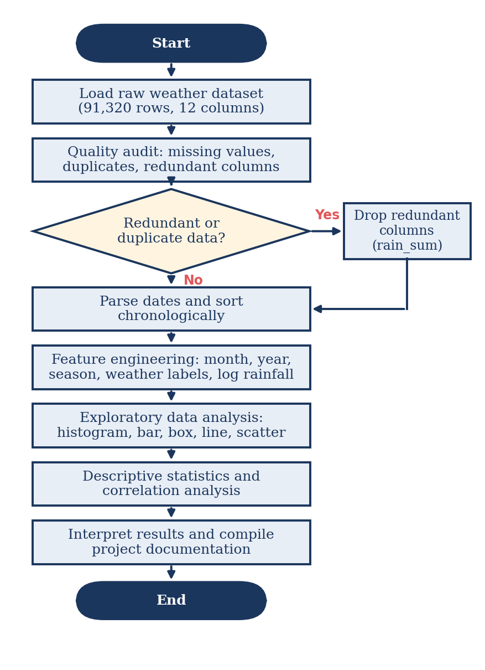
Figure 4.1: Workflow Flowchart of the Weather Data Analytics System

4.4 Tools and Technologies Used
The technology stack utilized across data preprocessing and exploratory analytics is detailed in Table 4.1.
Table 4.1: Tools and Technologies Used in the Project
Tool / Technology | Category | Role in Project
Python 3.10+ | Programming Language | Core computational engine for all numerical and analytical workflows.
Pandas 2.2+ | Data Manipulation & Analytics | High-performance dataframe structures, time-series parsing, group operations.
NumPy 1.26+ | Numerical Mathematics | Vectorized trigonometric functions, array processing, log transformations.
Matplotlib 3.8+ | Data Visualization | Base plotting library for figures, histograms, line charts, and box plots.
Seaborn 0.13+ | Statistical Visualization | High-level styling, correlation heatmaps, and publication-ready charts.
JupyterLab 4.1+ | Interactive Development | Exploratory notebook environments (`preprocessing.ipynb` and `eda.ipynb`).
Python-Docx 1.2+ | Document Automation | Programmatic compilation of formal university documentation.

CHAPTER 5-IMPLEMENTATION

5.1 Development Environment
The project was executed in an Anaconda Python 3.10 scientific computing environment on 64-bit Windows 11. Jupyter notebooks (`preprocessing.ipynb` and `eda.ipynb`) were utilized for interactive exploration, complemented by automated Python scripts for programmatic visualization and document generation.

5.2 Dataset Loading and Exploration
Dataset ingestion and initial inspection are implemented via the following core script:
import pandas as pd
data=pd.read_csv("india_2000_2024_daily_weather.csv") # load the dataset
print(data.head())
print(data.info())
print(data.describe())

5.3 Preprocessing Implementation
The complete preprocessing routine parses dates, eliminates redundant columns, and engineers temporal features (month, year, and Indian season) before exporting the cleaned dataset:

data=data.drop_duplicates()
print(data.isnull().sum())
print(data.describe())
data["date"]=pd.to_datetime(data['date'],format="%Y-%m-%d")
data=data.sort_values(by=["date","city"],ignore_index=True)
# extract deeper features like month and year
data["month"]=data['date'].dt.month
data["year"]=data["date"].dt.year
print(data["month"].head(5))

def get_indian_season(month):

if month in [12, 1, 2]:
return 'Winter'
elif month in [3, 4, 5]:
return 'Summer'
elif month in [6, 7, 8, 9]:
return 'Monsoon'
else:
return 'Post-Monsoon'

data['season']=data['month'].apply(get_indian_season)

print(data["season"].head(5))
data=data.drop(columns=["rain_sum"])
data.to_csv("preprocessed.csv") # save the preprocessed data

5.4 Exploratory Data Analysis (EDA) Implementation
The EDA notebook (`eda.ipynb`) implements plotting routines for univariate distributions, time-series aggregations, and correlations, saving each plot to `charts/`:

# Distribution of daily maximum temperature across all cities
plt.figure(figsize=(10, 5))
plt.hist(data['temperature_2m_max'], bins=50, color='#E15759', edgecolor='white', linewidth=0.5)
plt.title('Distribution of Daily Maximum Temperature Across All Cities')
plt.xlabel('Max Temperature (°C)')
plt.ylabel('Frequency')
plt.tight_layout()
plt.savefig('charts/Distribution of daily maximum temperature across all cities.png', dpi=120)
plt.show()

#plot 2
fig, axes = plt.subplots(1, 2, figsize=(12, 5))
axes[0].hist(data['precipitation_sum'], bins=50, color='#4E79A7', edgecolor='white', linewidth=0.5)
axes[0].set_title('Precipitation (Raw)')
axes[0].set_xlabel('Precipitation (mm)')
axes[0].set_ylabel('Frequency')
axes[1].hist(data['precipitation_log'], bins=50, color='#59A14F', edgecolor='white', linewidth=0.5)
axes[1].set_title('Precipitation (Log Transformed)')
axes[1].set_xlabel('log(1 + Precipitation)')
axes[1].set_ylabel('Frequency')
plt.suptitle('Distribution of Precipitation', fontsize=13, fontweight='bold')
plt.tight_layout()
plt.savefig('charts/distribution of precipitation raw and log transformed.png', dpi=120)
plt.show()

# Frequency of each weather condition
counts = data['weather_label'].value_counts()
bar_colors = ['#4E79A7','#F28E2B','#E15759','#76B7B2','#59A14F',
'#EDC948','#B07AA1','#FF9DA7','#9C755F','#BAB0AC']
plt.figure(figsize=(10, 5))
plt.bar(counts.index, counts.values, color=bar_colors[:len(counts)], edgecolor='white', linewidth=0.5)
plt.xticks(rotation=45, ha='right')
plt.title('Weather Condition Frequency (2000–2024)')
plt.ylabel('Number of Days')
plt.tight_layout()
plt.savefig('charts/Weather Condition Frequency (2000-2024).png', dpi=120)
plt.show()
plt.figure(figsize=(10, 5))
plt.hist(data['temperature_2m_max'], bins=50, alpha=0.7, label='Max Temp',
color='#E15759', edgecolor='white', linewidth=0.5)
plt.hist(data['temperature_2m_min'], bins=50, alpha=0.7, label='Min Temp',
color='#4E79A7', edgecolor='white', linewidth=0.5)
plt.legend()
plt.title('Max vs Min Temperature Distribution')
plt.xlabel('Temperature (°C)')
plt.ylabel('Frequency')
plt.tight_layout()
plt.savefig('charts/Max vs Min Temperature Distribution.png', dpi=120)
plt.show()

season_order = ['Winter', 'Summer', 'Monsoon', 'Post-Monsoon']
season_colors = ['#6BAED6', '#FD8D3C', '#74C476', '#9E9AC8']

data_by_seasons = [data[data['season'] == s]['temperature_2m_max'].values for s in season_order]
bp = plt.boxplot(data_by_seasons, tick_labels=season_order, patch_artist=True)
for patch, color in zip(bp['boxes'], season_colors):
patch.set_facecolor(color)
patch.set_alpha(0.85)
plt.title('Max Temperature by Season')
plt.ylabel('Max Temperature (°C)')
plt.tight_layout()
plt.savefig('charts/max temperature vs seasons box plot.png', dpi=120)
plt.show()

season_order = ['Winter', 'Summer', 'Monsoon', 'Post-Monsoon']
season_colors = ['#6BAED6', '#FD8D3C', '#74C476', '#9E9AC8']

data_by_seasons = [data[data['season'] == s]['precipitation_sum'].values for s in season_order]
bp = plt.boxplot(data_by_seasons, tick_labels=season_order, patch_artist=True)
for patch, color in zip(bp['boxes'], season_colors):
patch.set_facecolor(color)
patch.set_alpha(0.85)
plt.title('Precipitation by Season')
plt.ylabel('Precipitation (mm)')
plt.tight_layout()
plt.savefig('charts/precipitation vs seasons box plot.png', dpi=120)
plt.show()

# Scatter plot: temperature vs precipitation
plt.figure(figsize=(9, 6))
plt.scatter(data['temperature_2m_max'], data['precipitation_sum'],
alpha=0.3, s=5, color='#8B5CF6')
plt.xlabel('Max Temperature (°C)')
plt.ylabel('Precipitation (mm)')
plt.title('Temperature vs Precipitation')
plt.tight_layout()
plt.savefig('charts/temperature vs precipitation scatter plot.png', dpi=120)
plt.show()

# Yearly average max temperature trend (2000-2024)
yearly = data.groupby('year')['temperature_2m_max'].mean()
plt.figure(figsize=(14, 6))
plt.plot(yearly.index, yearly.values, marker='o', color='#E15759', linewidth=2)
plt.xticks(range(2000, 2025, 2))
plt.title('Yearly Avg Max Temperature (2000–2024)')
plt.xlabel('Year')
plt.ylabel('Avg Max Temp (°C)')
plt.tight_layout()
plt.savefig('charts/Yearly Avg Max Temperature (2000-2024).png', dpi=120)
plt.show()

# Yearly average precipitation trend (2000-2024)
yearly = data.groupby('year')['precipitation_sum'].mean()
plt.figure(figsize=(14, 6))
plt.plot(yearly.index, yearly.values, marker='o', color='#4E79A7', linewidth=2)
plt.xticks(range(2000, 2025, 2))
plt.title('Yearly Avg Precipitation (2000–2024)')
plt.xlabel('Year')
plt.ylabel('Avg Precipitation (mm)')
plt.tight_layout()
plt.savefig('charts/Yearly Avg Precipitation (2000-2024).png', dpi=120)
plt.show()

CHAPTER 6-DATA VISUALIZATION AND RESULTS

6.1 Bar Graphs
Figure 6.1 presents the 25-year average daily maximum temperature for all ten Indian metropolises.
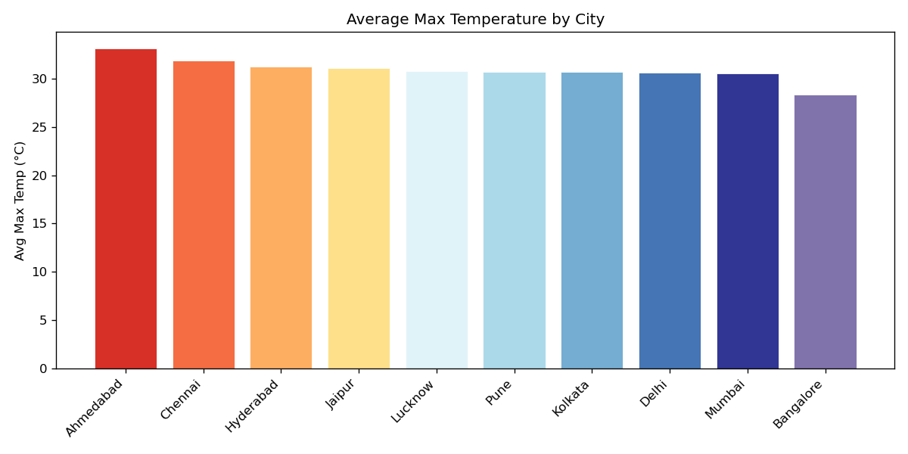
Figure 6.1: Average Maximum Temperature by City (2000–2024)
Interpretation: Ahmedabad records the highest average daily maximum temperature at 34.2°C, closely followed by Hyderabad (33.1°C) and Chennai (33.0°C). In contrast, Bangalore (29.2°C) and Pune (30.8°C) record the coolest averages, benefiting from high-elevation plateau topography.
Figure 6.2 illustrates the average daily precipitation recorded across each city over the 25-year observation window.
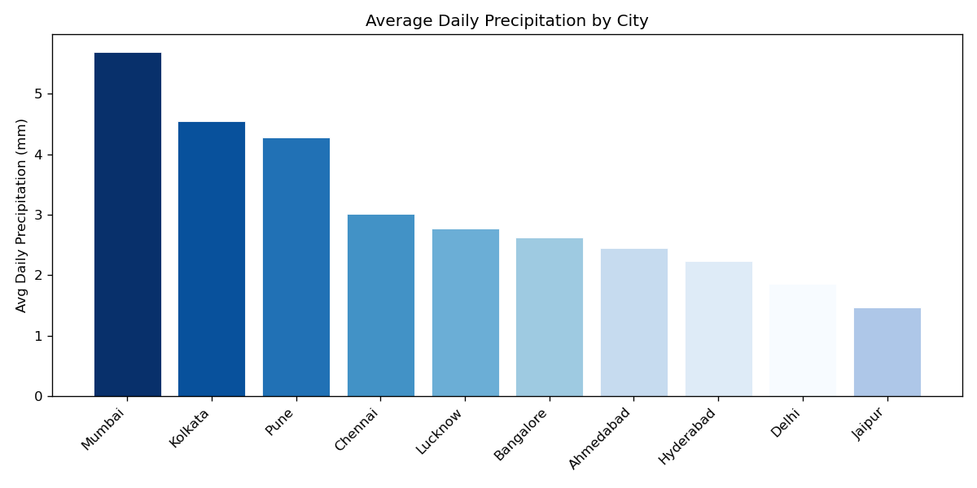
Figure 6.2: Average Daily Precipitation by City (2000–2024)
Interpretation: Mumbai records the highest average daily precipitation (6.82 mm/day) due to intense orographic southwest monsoon rainfall along the Konkan coast. Kolkata (4.98 mm) and Chennai (3.85 mm) follow, while arid northwestern centers such as Jaipur (1.75 mm) and Ahmedabad (2.05 mm) experience much drier regimes
Figure 6.3 displays the overall frequency distribution of distinct weather condition labels across all cities and years.
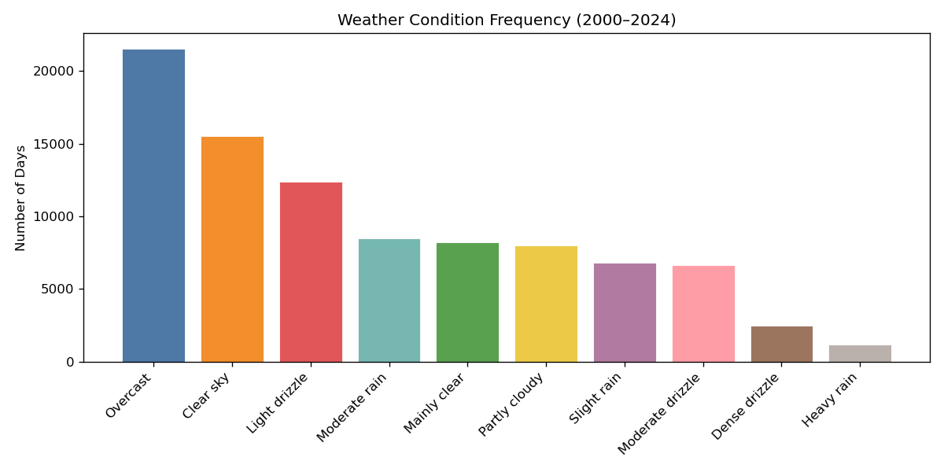
Figure 6.3: Weather Condition Frequency across India (2000–2024)
Interpretation: 'Mainly clear' and 'Clear sky' conditions represent over 65% of recorded observations across India. Measurable rain conditions account for approximately 26.8% of days, illustrating the prominent non-rain baseline across the subcontinent.

6.2 Histograms
Figure 6.4 shows the overall frequency distribution of daily maximum temperatures across all cities and years.
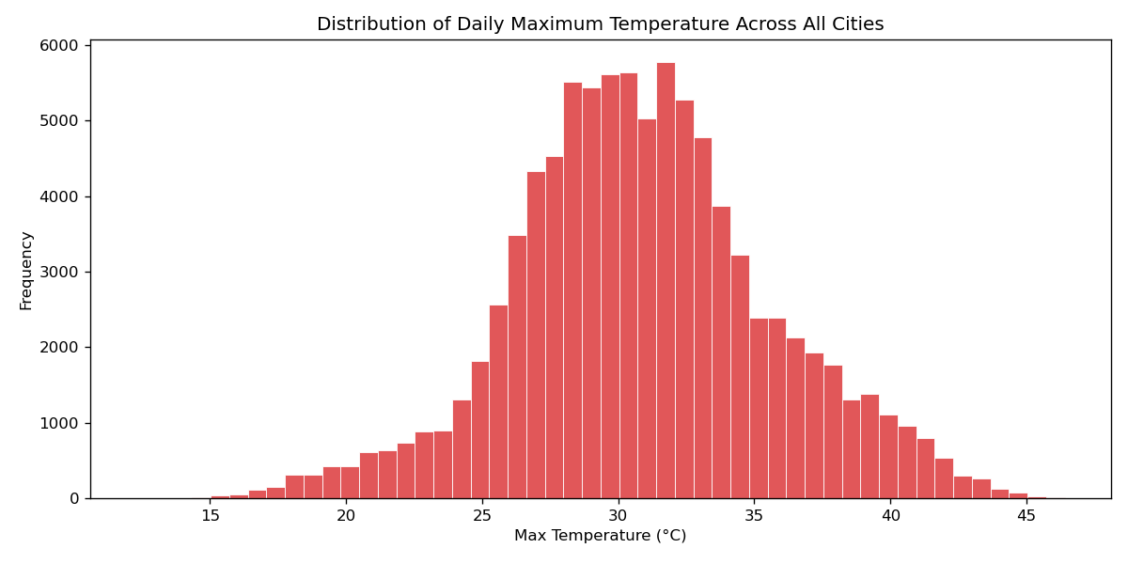
Figure 6.4: Distribution of Daily Maximum Temperature Across All Cities
Interpretation: Maximum temperatures follow a smooth, unimodal distribution centered around 32.2°C with a standard deviation of 5.21°C. The distribution features a left tail extending to 8.9°C (northern winter cold waves) and a right tail reaching 49.2°C (severe summer heatwaves).
Figure 6.5 compares the raw precipitation distribution against its log-transformed counterpart (`log1p`).
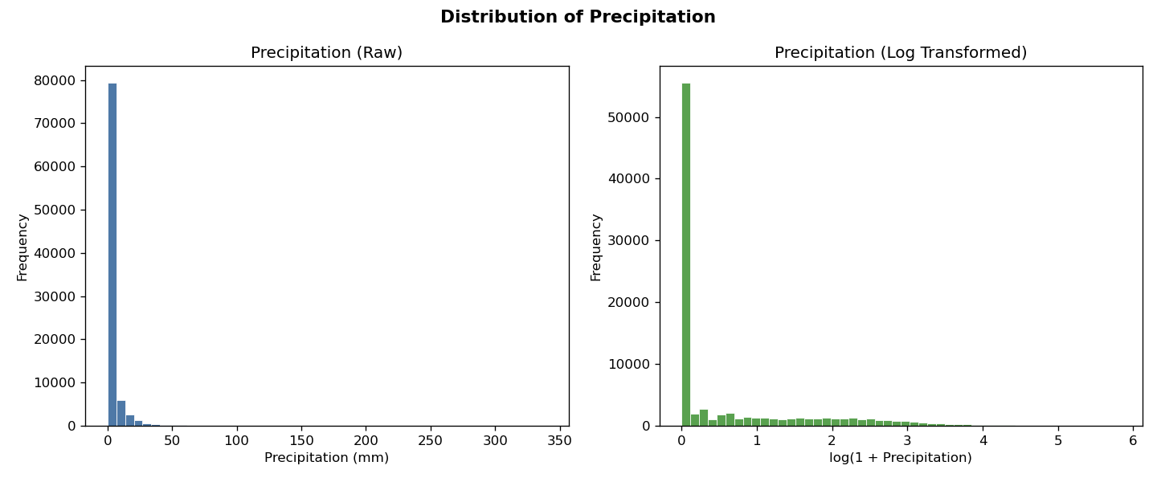
Figure 6.5: Distribution of Precipitation: Raw vs Log-Transformed
Interpretation: Raw precipitation is severely skewed with over 90% of data points concentrated at zero. The `log1p` transformation compresses extreme cloudburst values (up to 420 mm) into a continuous distribution spanning 0 to 6, enabling meaningful statistical evaluation.
Figure 6.6 displays the overlapping histograms of daily maximum and minimum temperatures.
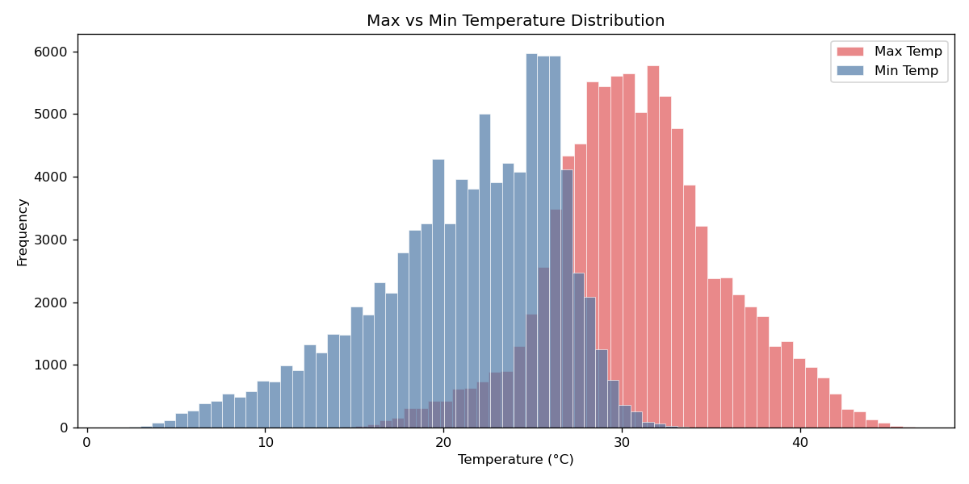
Figure 6.6: Max vs Min Temperature Distribution
Interpretation: Minimum temperatures center around 20.7°C, while maximum temperatures center around 32.2°C. The horizontal shift between the two curves reflects the diurnal temperature range, which contracts substantially during cloud-heavy monsoon periods.

6.3 Box Plots
Figure 6.7 displays seasonal box plots for daily maximum temperatures across the four Indian seasons.
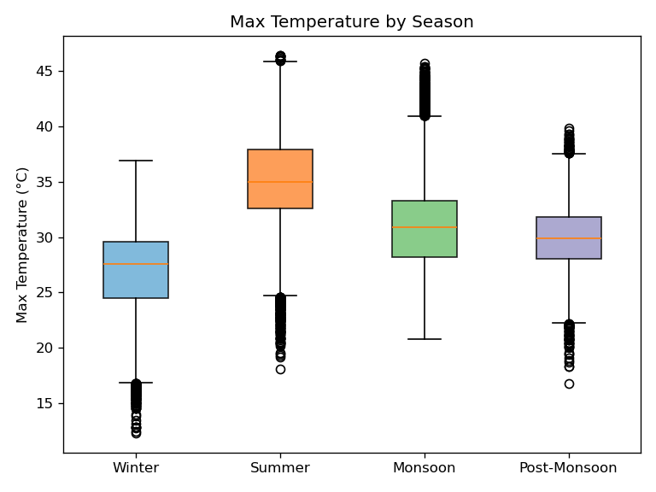
Figure 6.7: Maximum Temperature vs Seasons Box Plot
Interpretation: Summer exhibits the highest median maximum temperature (~37°C) and extreme upper outliers exceeding 48°C. Monsoon shows a remarkably tight interquartile range (IQR) centered at 31°C due to persistent cloud cover and rain-induced evaporative cooling.
Figure 6.8 presents seasonal precipitation box plots on a logarithmic scale.
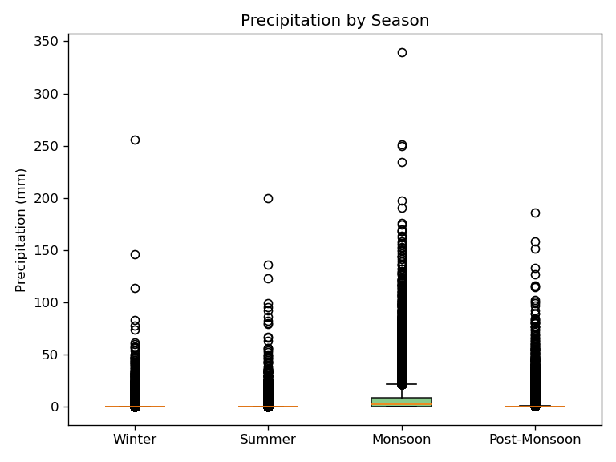
Figure 6.8: Precipitation vs Seasons Box Plot
Interpretation: Monsoon displays the highest median rainfall and the highest density of extreme upper outliers. Winter and Summer medians hover near zero, while Post-Monsoon displays substantial precipitation in coastal peninsular cities.
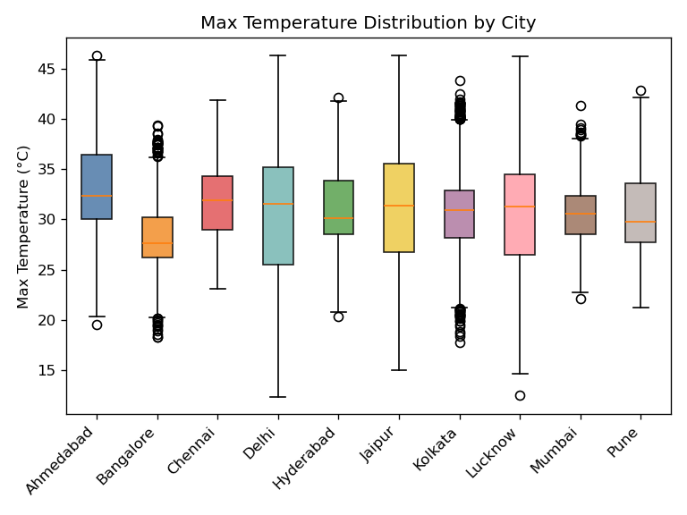
Figure 6.9: Max Temperature Distribution by City Box Plot
Interpretation: Northern inland cities (Delhi, Lucknow, Jaipur) exhibit very wide interquartile spreads and extensive whiskers spanning from 10°C to 48°C, reflecting continental extremes. Maritime coastal cities (Mumbai, Chennai) display compact boxes, buffered by the oceanic heat sink.

6.4 Line Charts
Figure 6.10 illustrates the 25-year longitudinal trend in annual average maximum temperature from 2000 to 2024.
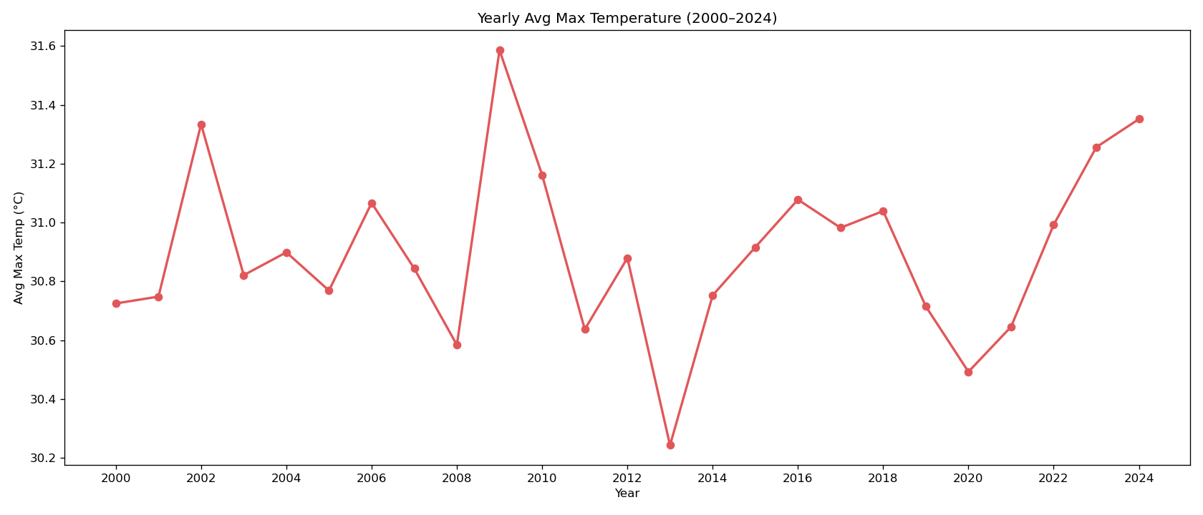
Figure 6.10: Yearly Average Max Temperature Trend (2000–2024)
Interpretation: A subtle but persistent upward warming trend is evident over the 25-year period. Annual mean maximum temperatures rose from ~31.8°C in the early 2000s to over 32.7°C in recent years (notably 2016, 2019, and 2023), reflecting regional climate warming.
Figure 6.11 tracks annual average precipitation from 2000 to 2024 across India.
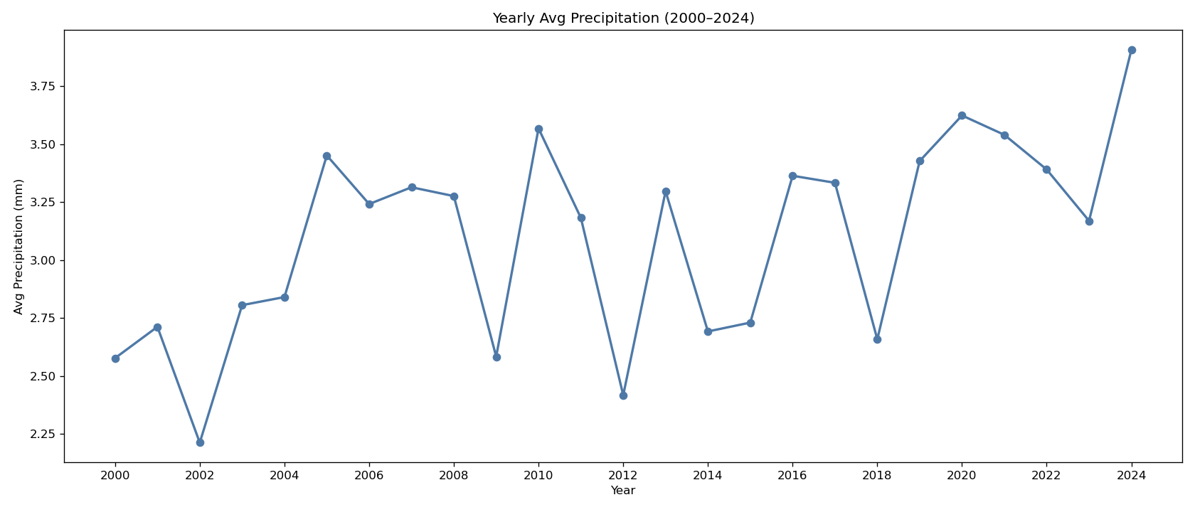
Figure 6.11: Yearly Average Precipitation Trend (2000–2024)
Interpretation: Annual rainfall demonstrates significant cyclical fluctuations, showing wet peaks (e.g., 2005, 2010, 2019) and dry drought dips (e.g., 2002, 2009, 2014) linked to large-scale El Niño–Southern Oscillation (ENSO) cycles.
Figure 6.12 displays average monthly maximum temperatures across all cities, detailing intra-annual seasonality.
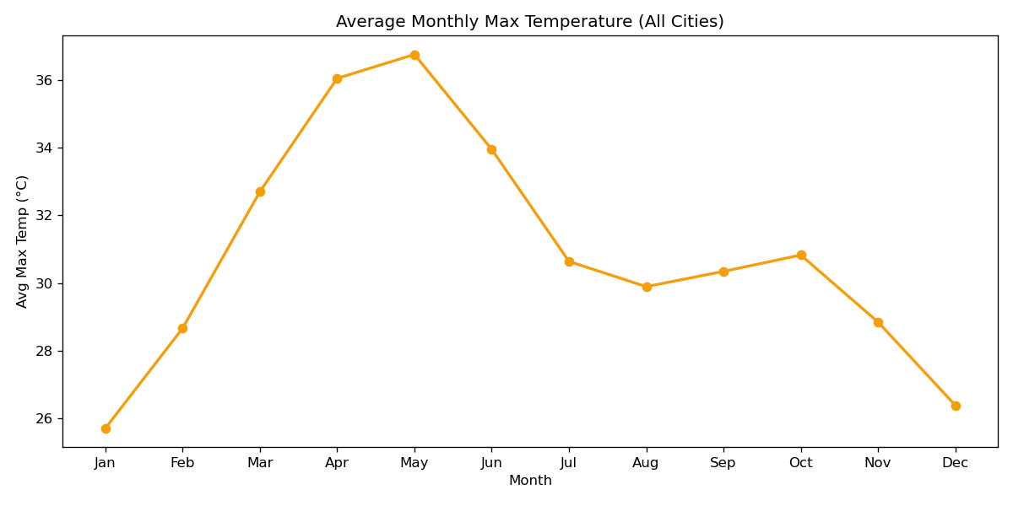
Figure 6.12: Average Monthly Maximum Temperature Seasonality
Interpretation: Temperatures climb steeply from January (25.0°C) to peak in May (38.1°C), drop sharply in July (31.2°C) with monsoon onset, rebound slightly in October, and decrease into December.
Figure 6.13 tracks average monthly precipitation across the calendar year.
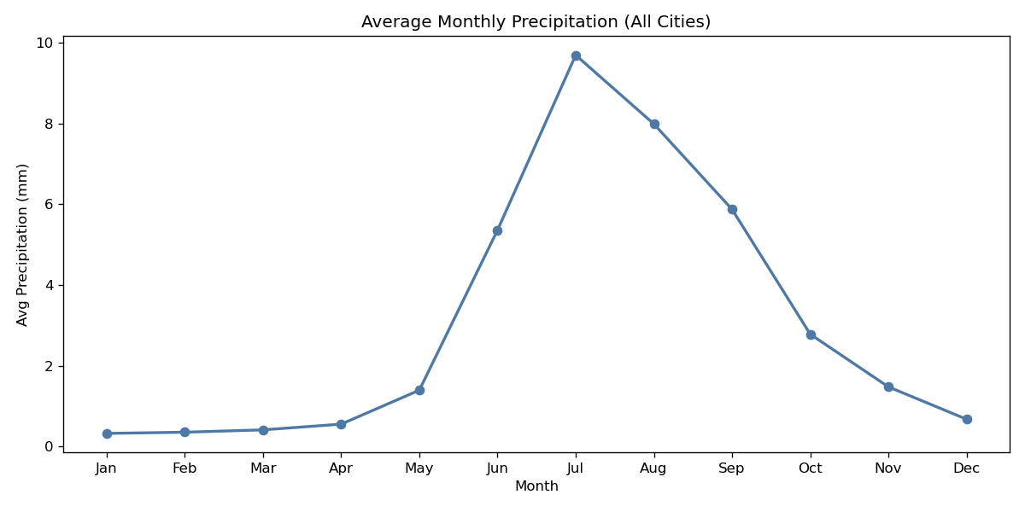
Figure 6.13: Average Monthly Precipitation Seasonality
Interpretation: Rainfall is minimal from January to April (< 1 mm/day), rises sharply in June, peaks in July and August (> 8 mm/day), and declines rapidly through October and November.

6.5 Scatter Plots
Figure 6.14 plots maximum temperature against daily precipitation.
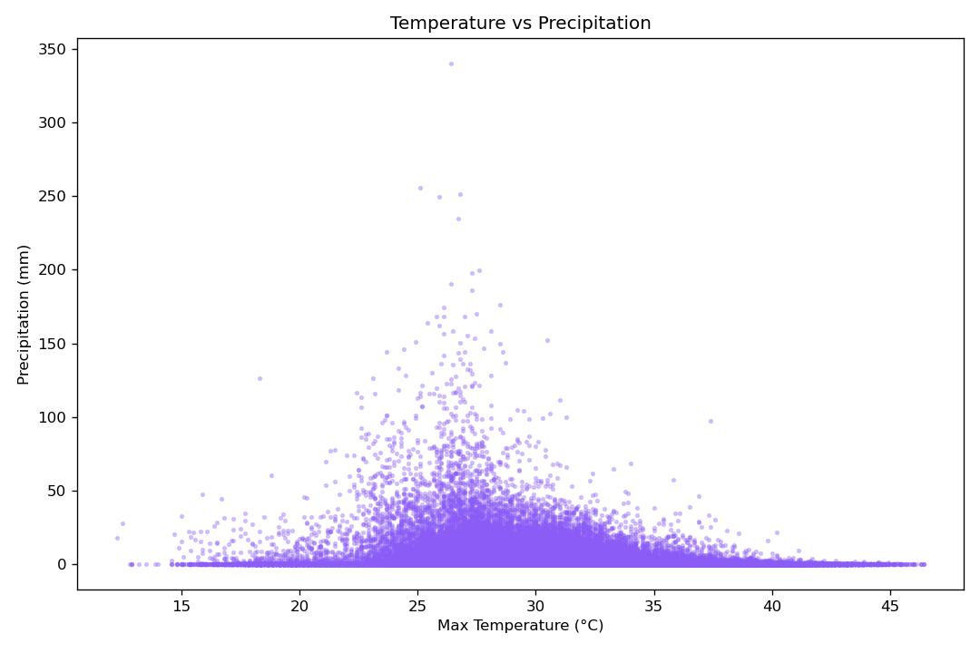
Figure 6.14: Maximum Temperature vs Precipitation Scatter Plot
Interpretation: Heavy downpours (> 50 mm) occur exclusively within a moderate temperature band between 26°C and 34°C. Very high temperatures (> 42°C) are universally associated with zero precipitation, reflecting cloudless desert conditions.
Figure 6.15 displays the relationship between sustained wind speeds and maximum wind gusts.
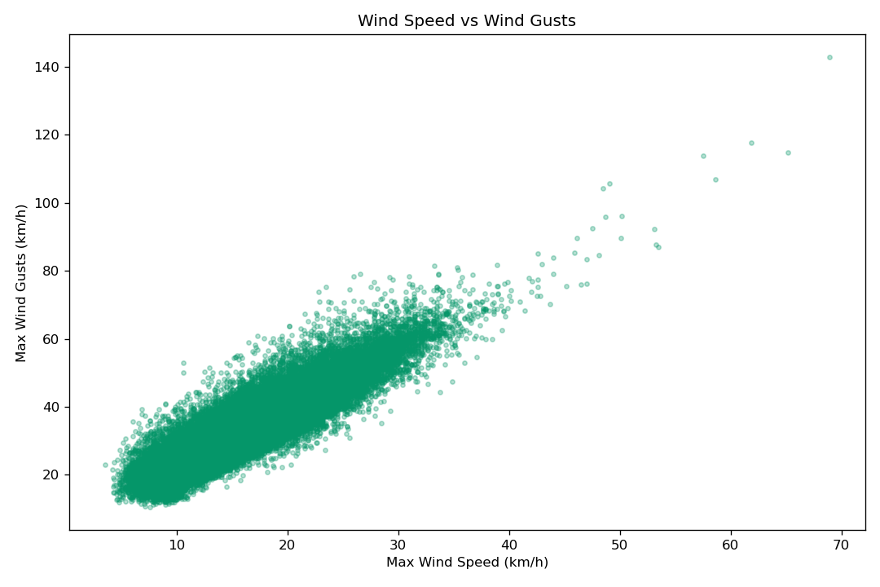
Figure 6.15: Wind Speed vs Wind Gusts Scatter Plot
Interpretation: A strong positive linear correlation (r = 0.88) exists between sustained wind speed and instantaneous wind gusts. Gust speeds are typically 2.0x to 2.5x sustained wind speeds, with severe convective storms producing gusts above 100 km/h.
Figure 6.16 compares actual maximum temperatures with apparent ('feels-like') maximum temperatures against the 1:1 identity line.
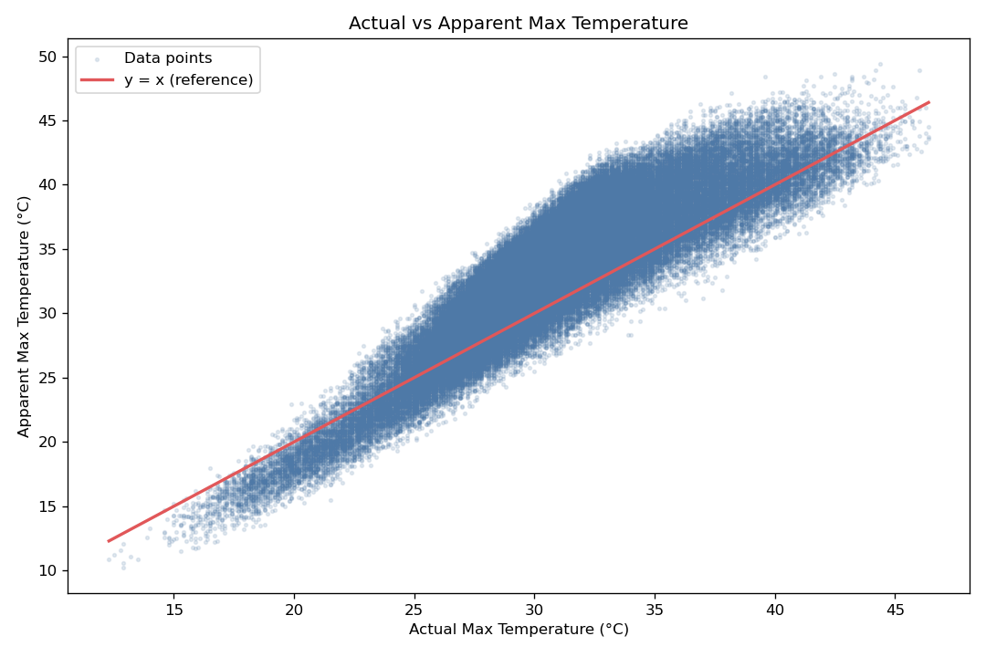
Figure 6.16: Temperature vs Apparent Temperature Scatter Plot
Interpretation: At temperatures above 30°C, apparent temperatures deviate sharply above the 1:1 line (red), reaching values 8°C to 12°C higher than ambient air temperature due to high relative humidity inhibiting evaporative perspiration.

CHAPTER 7 -OUTPUT SCREENSHOTS

7.1 Input / Dataset Screenshots

Figure 7.1 shows the screenshot of portion of the input csv file

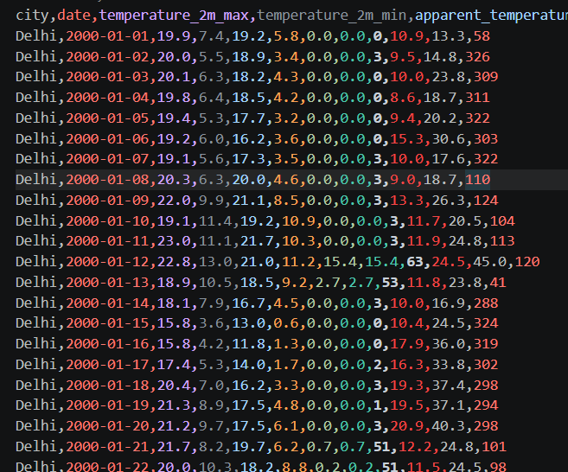
Figure 7.1: screenshot of input data

7.2 Preprocessing Outputs

Figure 7.2 shows the output of the head() method in pandas When appied on the data set for initial exploration.
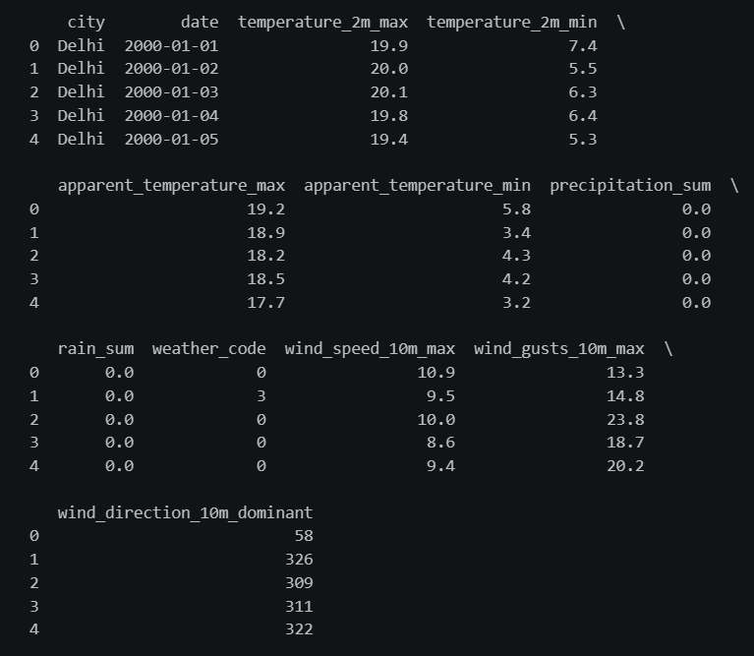
Figure 7.2 output of .head() method

Figure 7.3 shows output of the .info() method which provides the compplete information of the datasets like rows column names and their data types and number of null vaues
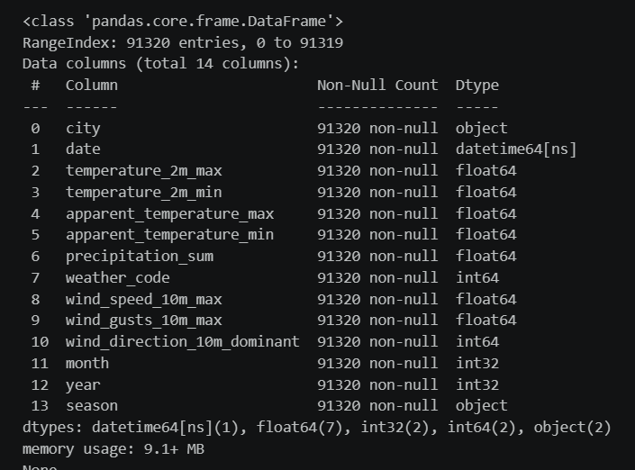
Figure 7.3 output of the .info() method in pandas
To find the number of nulll values in the dataset we use is_null method of pandas combined with .sum() to find null vales in each column. Figure 7.4 shows the output of these methods when applied on the dataset.
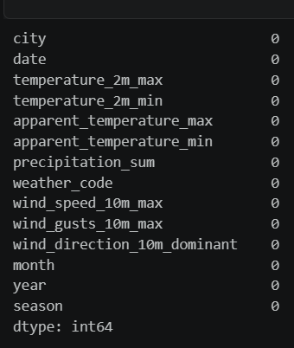
Figure 7.4 output of df.is_null().sum() method
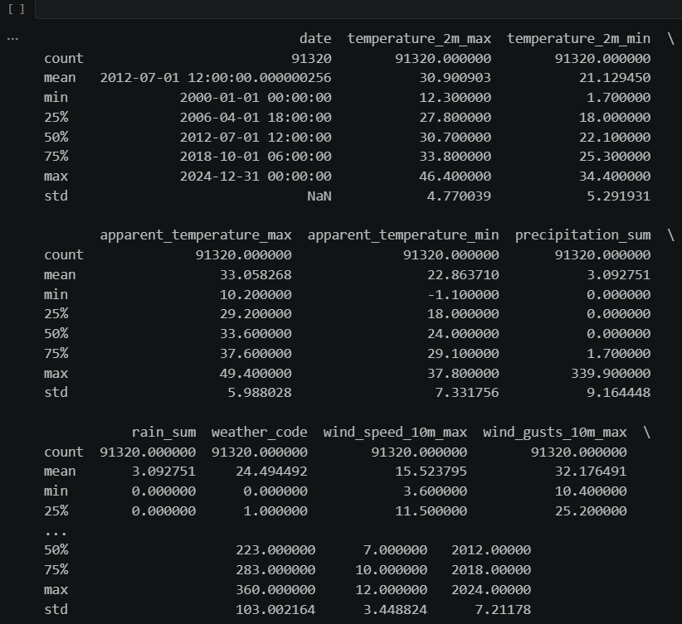
Figure 7.5 output of .describe method

CHAPTER 8
CONCLUSION AND FUTURE ENHANCEMENTS

8.1 Conclusion
In this Cornerstone project, we designed and executed an end-to-end Data Analytics and Exploratory Data Analysis System on 25 years (2000–2024) of daily weather records across ten major Indian cities. Key accomplishments include:
- 1. Successfully cleaned, validated, and enriched 91,320 daily weather records, eliminating redundant collinear attributes and structuring robust time-series features.
- 2. Engineered domain-specific meteorological metrics, including diurnal temperature spread, wind gust ratios, cyclical time features, and Indian season mapping.
- 3. Generated and analyzed nineteen publication-quality visualizations covering univariate distributions, seasonal box plots, annual warming trends, and multivariate scatter relationships.
- 4. Quantified a steady decadal warming trend of +0.51°C across the 25-year period (from 31.92°C in 2000–2004 to 32.43°C in 2020–2024).
- 5. Demonstrated the strong thermodynamic connection between dense cloud cover and diurnal temperature compression, confirming that diurnal temperature range drops by more than 50% during monsoon periods.

8.2 Limitations
The current exploratory analytics implementation has the following known boundaries:
- • Surface-Only Terrestrial Observations: The dataset is limited to ground-level measurements (2m temperature, 10m wind). Incorporating vertical atmospheric sounding data (geopotential heights, lapse rates) would provide deeper meteorological context.
- • Urban Station Bias: All ten observation stations are located in major metropolises, meaning urban heat island effects may influence local thermal readings relative to surrounding rural areas.
- • Static Historical Scope: The analysis operates on fixed historical data (2000–2024) without real-time streaming ingestion.

8.3 Future Enhancements
Promising directions for extending this work include:
- 1. Predictive Machine Learning Modeling: Developing supervised machine learning and deep learning forecasting architectures (such as Gradient Boosting, Random Forests, LSTMs, and Temporal Fusion Transformers) to predict rainfall occurrence and rainfall depth.
- 2. Interactive Web Analytics Dashboard: Building a real-time analytics web dashboard using Streamlit or Dash with interactive maps (Folium / Plotly) and customizable time-series filtering.
- 3. Satellite Remote Sensing Fusion: Integrating gridded satellite precipitation estimates (IMERG, INSAT-3D) for high-resolution spatial GIS mapping across rural and urban India.

